SIMATS ENGINEERING (SAVEETHA SCHOOL OF ENGINEERING)
Department of Computer Science and Engineering
CO2 ASSESSMENT TOOL 1 – Scenario-Based Requirement Analysis
Course Code: | CSA10 / CSA1063 | Course Title: | Software Engineering
CO Assessed: | CO2 | Assessment: | Scenario-Based Requirement Analysis
Weightage: | 20% | Total Marks: | 25
Student Name: | S. Roshni | Reg. No.: | 192525185
Date: | 23-10-2026 | Duration: | 60 minutes

ANNEXURE A – SOLUTION
Software Requirement Specification (SRS)
Distributed Online Collaboration Platform for Large Student Projects
Assigned Problem Statement No. 35
Domain | Education Technology / Collaborative Software Engineering Platform
Document version | 1.0 (Baseline) | Prepared according to IEEE 29148 / IEEE 830 structure
Contents | Part 1 Scenario analysis · Part 2 Functional & non-functional requirements · Part 3 Actors, use cases & use case diagram · Part 4 Complete SRS (Introduction, Problem description, Scope, Functional / Non-functional requirements, Use case descriptions, Data requirements, External interfaces, System features) · Part 5 Assumptions & constraints · Part 6 Validation of completeness and consistency
Diagrams included | Use Case Diagram · System Context Diagram · Activity (swimlane) Diagram · Entity-Relationship Diagram · Layered System Architecture

How to read this document: every requirement has a unique identifier (FR-xx, NFR-xx) and every use case has an identifier (UC-xx). The traceability tables in Part 6 show that each objective of the problem statement is covered by at least one requirement and one use case.

PART 1 – STUDY AND ANALYSIS OF THE SCENARIO

1.1 Understanding the Problem Statement
Large student projects (capstone projects, hackathon-scale products, inter-department mini-projects) are developed by several teams working at the same time on requirements, design, coding, testing, documentation and presentations. The problem statement identifies four recurring failures: duplicated work, merge conflicts, missed deadlines and inconsistent documentation. They arise because planning, source code, reviews, tests and documents live in separate tools (chat groups, shared drives, e-mail, personal laptops), so nobody has one reliable view of the project.
The requested solution is a single, web-based Distributed Online Collaboration Platform that coordinates tasks, requirements, source-code contributions, reviews, testing, documentation and progress tracking. It must integrate Git-based workflows, issue management, role-based access, containerised development environments, automated testing, CI/CD and project dashboards, and must keep the project history and audit trails.

1.2 Business Domain
Aspect | Analysis
Industry / domain | Education technology (EdTech) combined with DevOps-style software-engineering tooling. The platform is a project-based-learning management and collaboration system for engineering institutions.
Type of system | Multi-tenant, web-based, distributed system integrating several external services (Git hosting, CI/CD runners, container engine, identity provider, messaging).
Business value | Better teamwork, higher software quality, objective evidence of contribution for assessment, early visibility of schedule risk. Usage is term-based with sharp peaks before milestone reviews and final submission.

1.3 Stakeholders
Stakeholder | Role / interest | Key needs from the platform
Students (team members) | Do the project work in sub-teams (requirements, design, coding, testing, documentation). | Clear tasks, conflict-free merging, quick feedback from automated tests, ready-to-use development environment, shared documents.
Team Leads / Project Managers | Plan work, balance load, approve merges, report progress. | Task assignment, milestone tracking, risk visibility, control over branches and pipelines.
Faculty supervisors / mentors | Guide and evaluate the projects. | Progress dashboards, contribution evidence, review history, reports and audit trail for fair assessment.
Reviewers (peer / senior students / faculty) | Review code and documents. | Review queue, inline comments, approval workflow.
System administrator / IT staff | Install, secure, operate and support the platform. | User and role management, resource quotas, monitoring, backup, integration settings.
Department / institution | Owns the academic programme and data. | Compliance with data-protection rules, low cost, standardised engineering practices across projects.
External systems | Identity provider, Git hosting, CI/CD runners, container engine, e-mail / chat gateway. | Stable, documented, standards-based interfaces.

1.4 Existing Challenges and How the Platform Responds
# | Existing challenge | Impact on the project | System response (requirement)
1 | Teams work in parallel without a shared task view. | Duplicated work, unclear ownership. | Central task board with ownership and duplicate warning (FR-08, FR-11).
2 | Code shared through zip files / copy-paste or unstructured Git usage. | Merge conflicts, lost changes, broken main branch. | Branch workflow, protected branches, conflict detection, mandatory review (FR-18 – FR-22).
3 | Testing is manual and done late. | Defects discovered at demo time; low quality. | Automatic build and test on every pull request (FR-27 – FR-29).
4 | 'Works on my machine' – different tool versions and set-ups. | Wasted days on set-up; inconsistent results. | Containerised, reproducible development environments (FR-24 – FR-26).
5 | Documents are edited in many copies by different people. | Inconsistent, outdated documentation. | Collaborative, versioned documents and requirement baselines (FR-13 – FR-16).
6 | Progress is reported verbally; risks are noticed late. | Missed deadlines; supervisors cannot intervene in time. | Dashboards, risk register and automatic risk flags (FR-33 – FR-35).
7 | No evidence of who did what. | Unfair assessment; disputes. | Contribution statistics, audit trail, project history (FR-23, FR-38, FR-39, FR-42).

1.5 System Objectives and Expected Outcomes
Objective (from problem statement) | Measurable target
O1 Manage project teams, tasks, milestones and responsibilities | 100% of tasks have an owner, priority and due date; each milestone has linked tasks.
O2 Support collaborative requirements and documentation | All requirements are versioned and traceable to tasks and tests; one baseline document set per project.
O3 Integrate version control and code reviews | No direct commits to main; every merge has ≥ 1 approved review.
O4 Provide automated testing and CI/CD | Every pull request triggers the pipeline; failing checks block the merge.
O5 Track project progress and risks | Dashboard shows live status; risk flags raised automatically.
O6 Support containerised development environments | Environment ready in ≤ 2 min from a standard image.
O7 Maintain project history and audit trails | Every significant action recorded; history retained ≥ 3 years.

Expected outcome | How it is achieved
Improved collaboration among student teams | Shared boards, reviews, mentions, notifications.
Reduced duplicated work and merge conflicts | Duplicate-task warning; short-lived feature branches; early conflict detection.
Improved project visibility | Dashboards and reports for team leads and supervisors.
Stronger software-engineering practices | Mandatory reviews, CI, templates, traceability.
Improved quality through testing and reviews | Automated tests, coverage reports, quality gates.
Better project-management evidence | Audit trail, contribution statistics, exportable reports.

PART 2 – FUNCTIONAL AND NON-FUNCTIONAL REQUIREMENTS
Requirements are written as testable statements and prioritised using the MoSCoW scheme (Must have / Should have / Could have). 'The system shall' is implied in every functional requirement.

2.1 Functional Requirements
A. User & Access Management
ID | Requirement | Priority | Use case
FR-01 | Authenticate users through institutional single sign-on (OIDC/SAML) with a local-account fallback for external mentors. | Must | UC-01
FR-02 | Enforce role-based access control (RBAC) with roles: Administrator, Faculty Supervisor, Team Lead, Student Member, Reviewer and read-only Observer; permissions apply to every project, repository, document and dashboard. | Must | UC-03
FR-03 | Allow the Administrator to create, deactivate and bulk-import user accounts from a student roster (CSV). | Should | UC-03
FR-04 | Apply automatic session time-out and multi-factor authentication for privileged (Administrator / Supervisor) accounts. | Should | UC-01
B. Project, Team & Task Management
ID | Requirement | Priority | Use case
FR-05 | Create a project with title, description, timeline, supervisor and multiple sub-teams (requirements, design, coding, testing, documentation, presentation). | Must | UC-02
FR-06 | Add members to teams, assign roles and nominate a Team Lead; record responsibilities of each member. | Must | UC-02
FR-07 | Define milestones with due dates and expected deliverables and track their completion. | Must | UC-05
FR-08 | Create, assign, prioritise and update tasks (issues) following the workflow To Do → In Progress → In Review → Done. | Must | UC-04
FR-09 | Link each task to requirements, pull requests, commits and test results (two-way navigation). | Must | UC-04, UC-08
FR-10 | Provide Kanban-board and list views of tasks with filters (assignee, team, milestone, priority, status). | Should | UC-04
FR-11 | Warn the user about possible duplicate or overlapping tasks when a new task is created (title/description similarity check). | Should | UC-04
FR-12 | Support task dependencies, due dates and automatic reminders for approaching or missed deadlines. | Should | UC-05, UC-19
C. Requirements & Documentation
ID | Requirement | Priority | Use case
FR-13 | Create, version and baseline requirements (functional / non-functional) with priority, owner and status. | Must | UC-06
FR-14 | Provide collaborative editing of project documents (SRS, design, test plan, report) with version history, comments and concurrent-edit protection. | Must | UC-06
FR-15 | Offer document templates (SRS, design document, test plan, presentation outline) to keep documentation consistent across teams. | Should | UC-06
FR-16 | Generate a requirements-traceability matrix automatically (requirement ↔ task ↔ code change ↔ test). | Must | UC-06, UC-14
FR-17 | Export documents and reports to PDF, DOCX and Markdown. | Could | UC-06, UC-17
D. Version Control & Code Review
ID | Requirement | Priority | Use case
FR-18 | Create and manage a Git repository for each team, with protected branches (main / release). | Must | UC-08
FR-19 | Support a branch-based workflow: create feature branches, push commits and raise pull requests linked to tasks. | Must | UC-08
FR-20 | Support code review with inline comments, approve / request-changes decisions and a configurable minimum number of reviewers. | Must | UC-09
FR-21 | Detect merge conflicts before merging, show the conflicting files and block the merge until they are resolved. | Must | UC-10, UC-11
FR-22 | Prevent direct commits to protected branches; allow merge only after required approvals and passing automated checks. | Must | UC-10
FR-23 | Show contribution statistics per member and per team (commits, pull requests, reviews, tasks closed). | Should | UC-14, UC-18
E. Containerised Development Environments
ID | Requirement | Priority | Use case
FR-24 | Provision on demand a reproducible containerised development environment from a standard image / Dockerfile defined for the repository. | Must | UC-07
FR-25 | Apply CPU / memory / storage quotas per environment, auto-suspend idle environments and auto-expire unused ones without losing the persistent workspace volume. | Should | UC-07
FR-26 | Give browser-based IDE or SSH access to a provisioned environment. | Could | UC-07
F. Automated Testing & CI/CD
ID | Requirement | Priority | Use case
FR-27 | Trigger CI pipelines automatically on push, pull-request and merge events through webhooks. | Must | UC-12
FR-28 | Execute build, static analysis, unit tests and integration tests inside isolated containers. | Must | UC-12
FR-29 | Publish test results and code coverage on the pull request and block the merge when mandatory checks fail. | Must | UC-12, UC-10
FR-30 | Allow pipelines to be defined as code (YAML) using shared templates; only Team Lead / Administrator can edit protected pipeline stages. | Should | UC-20
FR-31 | Deploy a merged build to a staging / preview environment automatically and support one-click rollback. | Should | UC-13
FR-32 | Store build artefacts and logs with a configurable retention period. | Should | UC-12, UC-13
G. Progress Tracking, Dashboards & Risk
ID | Requirement | Priority | Use case
FR-33 | Display project dashboards: milestone completion, burn-down, task status, pull-request/review turnaround, build health and test coverage. | Must | UC-14
FR-34 | Maintain a risk register (description, probability, impact, owner, mitigation, status). | Should | UC-15
FR-35 | Raise automatic risk flags for overdue tasks, stalled pull requests, repeatedly failing builds and inactive members. | Should | UC-15, UC-19
FR-36 | Generate progress and contribution reports (PDF / CSV) for supervisors. | Should | UC-17
H. Notification, Audit, History & Administration
ID | Requirement | Priority | Use case
FR-37 | Send in-app, e-mail and chat notifications for assignments, review requests, build results, mentions and deadlines; users can set preferences. | Must | UC-19
FR-38 | Keep an append-only audit trail of significant actions (who, what, when, from where) that can be searched and exported. | Must | UC-16
FR-39 | Maintain complete project history (documents, requirements, code, decisions) and allow earlier versions to be viewed and restored. | Must | UC-16, UC-06
FR-40 | Provide administrative configuration for integrations, pipeline defaults, quotas and retention policies. | Should | UC-20
FR-41 | Archive a project at the end of a term: repositories and documents become read-only and the evidence is retained for evaluation. | Should | UC-02, UC-16
FR-42 | Let faculty record evaluation remarks and scores against milestones and individual members. | Should | UC-18

Summary: 42 functional requirements – 23 Must-have, 17 Should-have, 2 Could-have.

2.2 Non-Functional Requirements
Each non-functional requirement carries a measurable acceptance criterion so that it can be verified during testing.
ID | Category | Requirement | Measure / acceptance criterion
NFR-01 | Performance | Pages and dashboards load quickly under normal load. | 95% of page loads ≤ 2 s with 1,000 concurrent users; dashboard refresh ≤ 5 s.
NFR-02 | Performance | API calls respond promptly. | 95th-percentile read API latency ≤ 500 ms; write API ≤ 1 s.
NFR-03 | Performance | CI pipelines and environments start quickly. | Pipeline queued → running ≤ 30 s (normal load); dev environment ready ≤ 2 min.
NFR-04 | Scalability | The platform grows with the number of teams without redesign. | Supports 5,000 users, 500 teams, 10,000 repositories; stateless services scale horizontally; CI runners auto-scale.
NFR-05 | Security | Data is protected in transit and at rest. | TLS 1.2+ for all traffic; AES-256 encryption at rest; passwords hashed with bcrypt/Argon2.
NFR-06 | Security | Access follows least privilege and common web-security guidance. | RBAC checks on every request; OWASP Top-10 controls; secrets stored in a vault, never in repositories.
NFR-07 | Security | Containers are isolated from each other and from the host. | Non-root containers, resource limits, network policies, image vulnerability scan before use.
NFR-08 | Reliability | No loss of committed work; failures are recoverable. | RPO ≤ 1 hour (DB), RTO ≤ 4 hours; daily full + hourly incremental backups; failed pipeline jobs retried automatically (max 2).
NFR-09 | Availability | Available when students need it most. | 99.5% monthly availability during the academic term; ≥ 99.9% in the 48 h before declared submission deadlines; maintenance only in announced windows.
NFR-10 | Usability | Easy to learn and use for students from different disciplines. | New user completes 'create task → raise PR' in ≤ 30 min without training; ≥ 80% satisfaction in pilot survey.
NFR-11 | Usability | Accessible and responsive interface. | Conforms to WCAG 2.1 level AA; works on screens from 360 px (mobile) to desktop.
NFR-12 | Maintainability | Modular, well-documented and testable platform. | Loosely coupled services with OpenAPI documentation; ≥ 80% unit-test coverage; every release passes the platform's own CI.
NFR-13 | Maintainability | Operations team can monitor and diagnose problems. | Central logging, metrics and alerting; mean-time-to-diagnose ≤ 1 hour.
NFR-14 | Interoperability / Portability | Uses open standards and runs in common environments. | Standard Git protocol, REST/JSON APIs, OCI containers; latest two versions of Chrome, Edge, Firefox and Safari.
NFR-15 | Auditability | Actions are traceable and tamper-evident. | 100% of security-relevant actions logged; log entries cannot be modified or deleted by users; retained ≥ 3 years.
NFR-16 | Data privacy & compliance | Student data is handled lawfully. | Complies with India's DPDP Act 2023 and institutional data policy; personal data minimised; export / erase on request.
NFR-17 | Capacity | Storage is sufficient for a full term. | ≥ 5 TB repository / artefact storage with quota alerts at 80%.

PART 3 – ACTORS AND USE CASES

3.1 Actors
Actor | Type | Description
Student Team Member | Primary | Works on assigned tasks, writes code and documents, raises pull requests, reviews peers' work.
Team Lead / Project Manager | Primary (specialisation of Student Team Member) | Inherits all student abilities; additionally manages teams and milestones, approves merges, maintains the risk register, requests reports.
Faculty Supervisor | Primary | Monitors progress, reviews artefacts, evaluates teams and individuals, reads audit history.
System Administrator | Primary | Manages users, roles, quotas, pipelines and integrations.
Identity Provider (SSO) | Secondary | External system that authenticates users and returns identity and profile.
Git Hosting Service | Secondary | Stores repositories; sends push / pull-request / merge events; executes merges.
CI/CD Runner & Container Engine | Secondary | Builds, tests and deploys code; creates and destroys containerised environments.
Notification Service (e-mail / chat) | Secondary | Delivers alerts and digests to users.

Note: 'Reviewer' is a *role* (FR-02) that a Student Member, Team Lead or Faculty Supervisor plays for a given pull request, so it is not modelled as a separate actor.

3.2 Use Case List
ID | Use case | Actors | Brief description
UC-01 | Login & Authenticate | Student, Team Lead, Faculty, Admin; IdP | Included by every other use case (authentication and authorisation check).
UC-02 | Manage Projects & Teams | Admin, Team Lead | Create projects, teams, members; archive at term end.
UC-03 | Manage Roles & Access Control | Admin | Assign roles and permissions; (de)activate accounts.
UC-04 | Create & Assign Tasks / Issues | Student, Team Lead | Create, prioritise, assign and update tasks; duplicate warning.
UC-05 | Track Milestones & Deadlines | Student, Team Lead, Faculty | Define and follow milestones, due dates, reminders.
UC-06 | Collaborate on Requirements & Documents | Student, Faculty | Write, comment on and version requirements and documents.
UC-07 | Provision Containerised Dev Environment | Student; CI/Container Engine | Create a ready-to-code environment for a repository.
UC-08 | Commit Code & Raise Pull Request | Student; Git Service | Push branch and open pull request linked to a task. «include» UC-12.
UC-09 | Review Code | Student, Team Lead | Inline comments, approve / request changes.
UC-10 | Merge Branch | Team Lead; Git Service | Merge approved pull request into protected branch. «include» UC-09.
UC-11 | Resolve Merge Conflicts | Student; Git Service | Resolve conflicts. «extend» UC-10.
UC-12 | Run Automated Tests (CI) | CI/CD Runner | Build, static analysis, unit & integration tests.
UC-13 | Deploy Build (CD) | CI/CD Runner | Deploy merged build to staging / preview. «include» UC-12.
UC-14 | Monitor Progress Dashboard | Student, Team Lead, Faculty | View status, burn-down, build health, contribution charts.
UC-15 | Manage Project Risks | Team Lead, Faculty | Record and follow risks; see automatic risk flags.
UC-16 | View Audit Trail & Project History | Student, Faculty, Admin | Search history and audit log; restore earlier versions.
UC-17 | Generate Progress Reports | Team Lead, Faculty | Create PDF/CSV progress and contribution reports.
UC-18 | Evaluate Team Contributions | Faculty | Record remarks and scores using contribution evidence.
UC-19 | Send Notifications & Alerts | Notification Service | Notify users of assignments, reviews, results, deadlines. «extend» UC-09.
UC-20 | Configure CI/CD Pipelines | Admin, Team Lead; CI/CD Runner | Define pipeline templates, quality gates, defaults.

3.3 Use Cases per Actor
Actor | Major use cases
Student Team Member | UC-01, UC-04, UC-05, UC-06, UC-07, UC-08, UC-09, UC-11, UC-14, UC-16
Team Lead / Project Manager (inherits Student) | All student use cases plus UC-02, UC-10, UC-15, UC-17, UC-20
Faculty Supervisor | UC-01, UC-05, UC-06, UC-09 (as reviewer), UC-14, UC-15, UC-16, UC-17, UC-18
System Administrator | UC-01, UC-02, UC-03, UC-16, UC-20
Identity Provider | UC-01
Git Hosting Service | UC-08, UC-10, UC-11
CI/CD Runner & Container Engine | UC-07, UC-12, UC-13, UC-20
Notification Service | UC-19

3.4 Use Case Diagram
The diagram below follows UML 2.x notation: stick figures are actors, ellipses are use cases inside the system boundary, solid lines are associations, dashed arrows show «include» / «extend» relationships and the hollow-triangle arrow shows actor generalisation (Team Lead is a specialised Student Team Member). Because every use case needs a valid session, UC-01 is implicitly included by all other use cases; only its direct associations are drawn to keep the diagram readable.
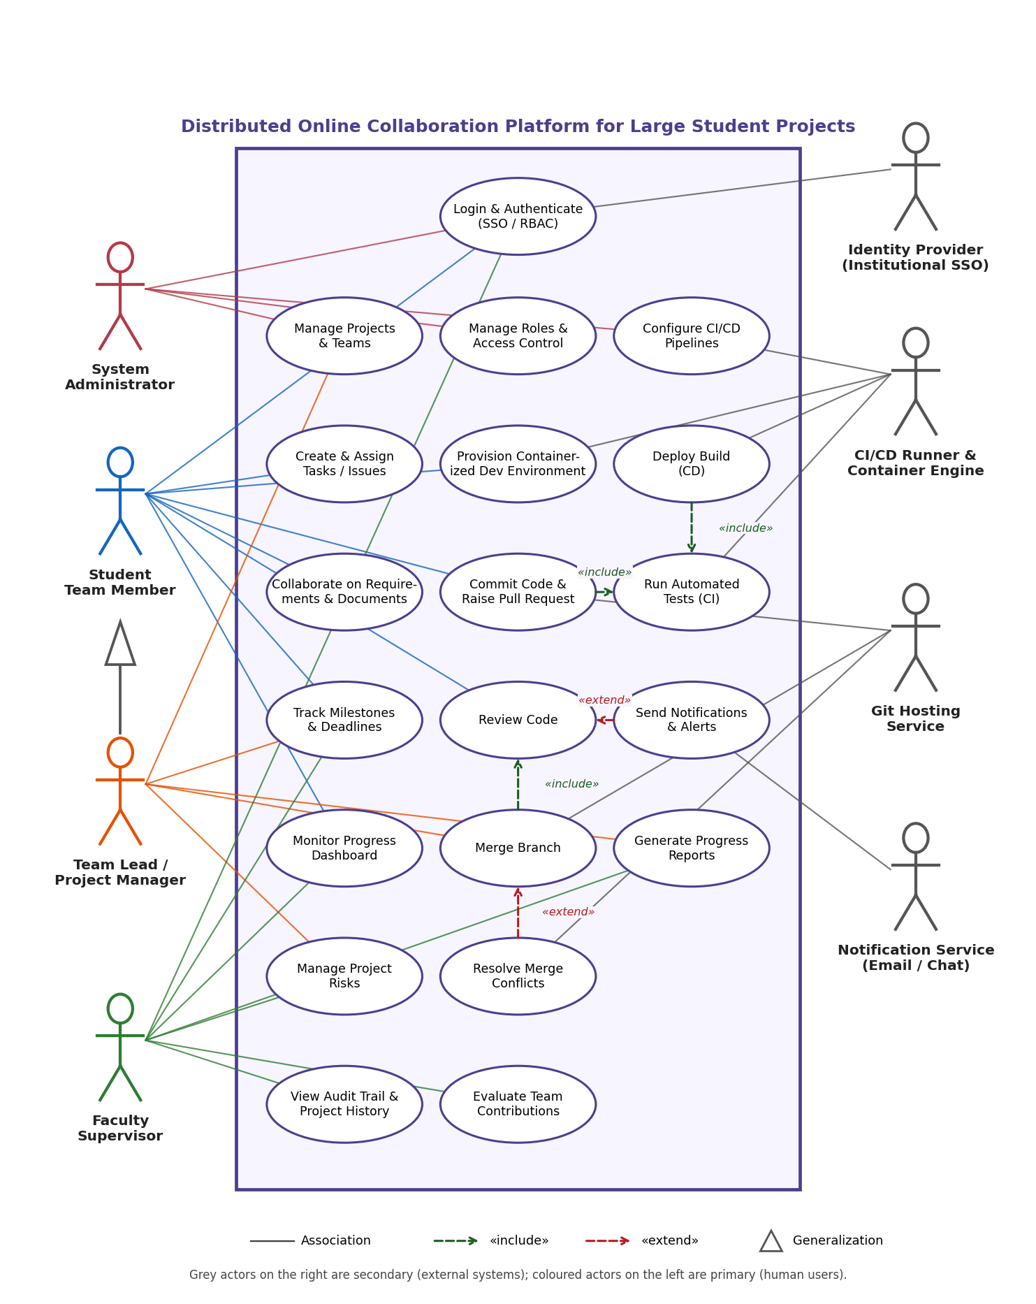
Figure 1: UML Use Case Diagram – Distributed Online Collaboration Platform
Relationship | Meaning
UC-08 «include» UC-12 | Raising a pull request always triggers automated tests.
UC-10 «include» UC-09 | A branch can be merged only after code review.
UC-13 «include» UC-12 | Deployment always runs after tests have passed.
UC-11 «extend» UC-10 | Conflict resolution occurs only when the merge detects conflicts.
UC-19 «extend» UC-09 | Notification is sent when a review is requested or completed (optional behaviour of review).
Team Lead → Student Team Member | Generalisation: Team Lead can do everything a Student can do.

PART 4 – SOFTWARE REQUIREMENT SPECIFICATION (SRS)
Distributed Online Collaboration Platform for Large Student Projects (DOCP) – Version 1.0

4.1 Introduction

4.1.1 Purpose
This document specifies the software requirements of the Distributed Online Collaboration Platform (DOCP). It describes what the platform must do and the qualities it must have, so that developers, testers, faculty and administrators share a common, verifiable understanding before design and implementation begin.

4.1.2 Intended audience
Faculty supervisors and project coordinators (approval), student development team (design / coding), testers (test-case derivation), system administrators (deployment planning) and the institution's IT / data-protection office (compliance review).

4.1.3 Document conventions
- Requirement IDs: FR-nn functional, NFR-nn non-functional, UC-nn use case, F-n system feature.
- Priority: Must (essential for first release), Should (important, can be scheduled after core), Could (desirable if time permits).
- 'Project' = one large student project with several teams; 'Team' = a sub-group responsible for a work area.

4.1.4 Definitions, acronyms and abbreviations
Term | Meaning
CI / CD | Continuous Integration / Continuous Delivery – automatic build, test and deployment of every change.
RBAC | Role-Based Access Control.
SSO / OIDC / SAML | Single sign-on and the open protocols used to implement it.
PR | Pull request – a proposal to merge a branch into another, reviewed before merging.
Container | Lightweight, isolated runtime package (OCI / Docker image instance) used for environments and pipelines.
Merge conflict | Situation where two branches change the same lines so Git cannot merge automatically.
Audit trail | Chronological, tamper-evident record of who did what and when.
RPO / RTO | Recovery Point Objective / Recovery Time Objective.
MoSCoW | Prioritisation method: Must, Should, Could, Won't.

4.1.5 References
- IEEE Std 830-1998 and ISO/IEC/IEEE 29148:2018 – Requirements engineering.
- I. Sommerville, Software Engineering, Pearson – requirements engineering chapters.
- R. S. Pressman & B. Maxim, Software Engineering: A Practitioner's Approach, McGraw-Hill.
- OMG Unified Modeling Language (UML) 2.5 specification.
- Assignment problem statement No. 35 and CSA10 CO2 assessment brief.

4.1.6 Overview of the document
Section 4.2 explains the problem, 4.3 fixes the scope, 4.4 and 4.5 consolidate the functional and non-functional requirements (full lists in Part 2), 4.6 describes the use cases, 4.7 specifies data, 4.8 external interfaces and 4.9 system features. Section 4.10 gives the architecture that satisfies the scalability and availability requirements.

4.2 Problem Description
In large student projects, 5 to 50 teams contribute to one deliverable. Teams use different tools and no common process, which leads to: duplicated and unassigned work, frequent merge conflicts and broken main branches, late discovery of defects because testing is manual, differing development set-ups, divergent copies of documents, and last-minute surprises because progress and risks are invisible to leads and supervisors. Supervisors also lack objective evidence of individual contribution.
DOCP solves this by giving every project one integrated workspace in which planning (tasks, milestones), requirements, documents, source code, reviews, tests, CI/CD, environments, dashboards and history are linked to each other and governed by role-based access.

4.2.1 Product perspective
DOCP is a new, self-contained web application that integrates standard external services (Git hosting, CI/CD runners, container engine, SSO provider, notification gateway) through published APIs and webhooks (see the context diagram in Section 4.8). It does not replace the institution's learning management system but can exchange grades and reports with it in future.

4.2.2 User classes and characteristics
User class | Characteristics | Frequency of use
Student Team Member | Second-to-final-year students, moderate Git knowledge, varied disciplines (software, data, design, documentation). | Daily
Team Lead | Experienced student; needs planning and control views. | Daily
Faculty Supervisor | Domain expert; low tolerance for complex tools; needs summaries. | Weekly, peak at reviews
System Administrator | Technical; manages infrastructure and security. | Occasional / on alert

4.2.3 Operating environment
Server side: Linux hosts or a Kubernetes cluster on campus or in a cloud region within the country, PostgreSQL database, object storage, OCI-compatible container runtime. Client side: latest two versions of Chrome, Edge, Firefox or Safari; Git client ≥ 2.30 for command-line users.

4.3 Scope of the System
In scope | Out of scope (this release)
User, role and project / team management  Task, milestone and issue tracking  Requirement and document collaboration with versioning  Git repository management, branching, pull requests, code review  Containerised development environments  Automated build, test, quality gates, staging deployment  Dashboards, risk register, reports  Notifications, audit trail, project history, archival | Production hosting of the students' own end-products  A native mobile application (responsive web only)  Plagiarism detection / code-similarity grading  Video conferencing and real-time chat server (only integration with an existing chat tool)  Payroll, fees or other academic administration  AI-based automatic grading

System boundary: everything inside the platform's web application, services and data stores is in scope; the Git server, CI runners and container engine are treated as components the platform *integrates and controls* through APIs; the identity provider and notification gateway are external systems.

4.4 Functional Requirements (Consolidated)
The complete requirement statements FR-01 to FR-42 are given in Part 2, Section 2.1. The table summarises them per module together with the system feature (Section 4.9) that realises them.
Module | Requirements | Count (Must / Should / Could) | Feature
A. User & Access Management | FR-01 – FR-04 | 4 (2 / 2 / 0) | F-1
B. Project, Team & Task Management | FR-05 – FR-12 | 8 (5 / 3 / 0) | F-2
C. Requirements & Documentation | FR-13 – FR-17 | 5 (3 / 1 / 1) | F-3
D. Version Control & Code Review | FR-18 – FR-23 | 6 (5 / 1 / 0) | F-4
E. Containerised Development Environments | FR-24 – FR-26 | 3 (1 / 1 / 1) | F-5
F. Automated Testing & CI/CD | FR-27 – FR-32 | 6 (3 / 3 / 0) | F-6
G. Progress Tracking, Dashboards & Risk | FR-33 – FR-36 | 4 (1 / 3 / 0) | F-7
H. Notification, Audit, History & Administration | FR-37 – FR-42 | 6 (3 / 3 / 0) | F-8

4.5 Non-Functional Requirements (Consolidated)
NFR-01 to NFR-17 (Part 2, Section 2.2) cover performance, scalability, security, reliability, availability, usability, maintainability, interoperability, auditability, privacy and capacity. Key quality targets that drive the architecture are:
- Performance: 95% of page loads ≤ 2 s at 1,000 concurrent users (NFR-01).
- Scalability: 5,000 users / 500 teams with horizontal scaling and auto-scaling CI runners (NFR-04).
- Security: TLS, encryption at rest, least-privilege RBAC, isolated containers (NFR-05 – NFR-07).
- Availability & reliability: 99.5% monthly (99.9% near deadlines), RPO ≤ 1 h, RTO ≤ 4 h (NFR-08, NFR-09).
- Usability & accessibility: 30-minute onboarding, WCAG 2.1 AA (NFR-10, NFR-11).

4.6 Use Case Descriptions
The most important use cases are described in detail below (preconditions, flows, alternatives and exceptions). The remaining use cases follow the same template.
UC-01 Login & Authenticate
Primary actor | Any user (Student, Team Lead, Faculty, Administrator)
Secondary actor | Identity Provider (SSO)
Goal | Establish a trusted session and the user's roles.
Preconditions | User has an institutional account; platform and IdP are reachable.
Main flow | 1. User opens the platform and chooses 'Sign in with institution'.  2. Platform redirects to the Identity Provider.  3. User authenticates at the IdP.  4. IdP returns a signed identity token.  5. Platform validates the token, creates / updates the user profile and loads roles.  6. Platform opens the user's dashboard.
Alternative flows | A1. Local account: user enters e-mail and password; privileged users additionally enter an MFA code (FR-04).  A2. First login: profile is created automatically from the token and a default Student role is assigned.
Exceptions | E1. Invalid / expired token → access denied, message shown, event logged.  E2. IdP unavailable → user told to retry; local-account login offered if allowed.  E3. Account deactivated → access denied.
Postconditions | Authenticated session with roles exists; login recorded in the audit trail.
Requirements | FR-01, FR-02, FR-04, FR-38, NFR-05, NFR-06

UC-04 Create & Assign Tasks / Issues
Primary actor | Team Lead (also Student Team Member for own tasks)
Goal | Record a unit of work with clear ownership, priority and deadline.
Preconditions | User is logged in and belongs to the team; a milestone exists.
Main flow | 1. User selects 'New task' on the board.  2. Enters title, description, priority, milestone, due date and optional linked requirement.  3. System checks for similar open tasks (FR-11).  4. User assigns an owner from the team and saves.  5. System stores the task in status 'To Do', writes an audit record and triggers UC-19 for the assignee.
Alternative flows | A1. Similar task found → user opens it instead, or confirms creating a new one.  A2. Task created from a requirement → requirement link is filled automatically.
Exceptions | E1. Mandatory field missing → validation message.  E2. Assignee not in team → rejected.  E3. Due date after milestone date → warning, user may override with a reason.
Postconditions | Task exists with owner, status and links; dashboards updated.
Requirements | FR-08, FR-09, FR-10, FR-11, FR-12, FR-37

UC-07 Provision Containerised Development Environment
Primary actor | Student Team Member
Secondary actor | CI/CD Runner & Container Engine
Goal | Obtain a ready-to-code, reproducible environment without manual set-up.
Preconditions | User is logged in, has write access to the repository, and the repository defines an environment image / Dockerfile; user's quota is not exhausted.
Main flow | 1. User selects a repository and branch and chooses 'Create environment'.  2. System checks permissions and quota.  3. System asks the container engine to start the environment from the configured image with the branch checked out.  4. Engine mounts a persistent workspace volume and returns the access URL.  5. System shows status 'Ready' and the browser-IDE / SSH link.
Alternative flows | A1. Existing suspended environment → it is resumed instead of a new one created.  A2. User requests a custom image from the approved list.
Exceptions | E1. Quota exceeded → request refused with explanation.  E2. Image build / pull fails → error and log shown; administrator alerted after repeated failures.  E3. Cluster capacity full → request queued with estimated wait time.
Postconditions | Environment running with owner, expiry time and resource limits; creation logged.
Requirements | FR-24, FR-25, FR-26, NFR-03, NFR-07

UC-08 Commit Code & Raise Pull Request
Primary actor | Student Team Member
Secondary actors | Git Hosting Service; CI/CD Runner (via «include» UC-12)
Goal | Submit finished work for review and automated verification.
Preconditions | User is logged in; a task is assigned to the user; a feature branch exists.
Main flow | 1. User commits changes and pushes the feature branch.  2. Git service notifies the platform (webhook).  3. User opens 'New pull request', selects source and target branch and the linked task.  4. System validates that the target is allowed and creates the pull request in status 'Open'.  5. System triggers the CI pipeline (UC-12).  6. System requests reviewers and sends notifications (UC-19).
Alternative flows | A1. Pull request created from the task page (branch name pre-filled).  A2. Draft pull request – no reviewers notified until marked 'Ready'.
Exceptions | E1. Push to protected branch → rejected (FR-22).  E2. No linked task → warning, creation allowed only if the project policy permits.  E3. Webhook delivery fails → platform polls the Git service every minute.
Postconditions | Pull request exists with pipeline run and review requests; task status becomes 'In Review'.
Requirements | FR-09, FR-19, FR-22, FR-27, FR-37

UC-09 Review Code
Primary actor | Reviewer (Student, Team Lead or Faculty)
Goal | Check quality and correctness before merging.
Preconditions | A pull request is 'Open' or 'Ready'; reviewer is not the author.
Main flow | 1. Reviewer opens the review queue and selects a pull request.  2. Reviewer reads the diff, test results and coverage.  3. Reviewer adds inline comments.  4. Reviewer selects 'Approve' or 'Request changes' and submits.  5. System records the decision and notifies the author.
Alternative flows | A1. Author pushes fixes → system marks previous approvals as stale and requests re-review.  A2. Reviewer reassigns the review to another qualified member.
Exceptions | E1. Author tries to approve own pull request → denied.  E2. Pipeline failed → reviewer sees a warning; approval is allowed but merge stays blocked.
Postconditions | Review decision stored; required approval count updated.
Requirements | FR-20, FR-29, FR-37, FR-38

UC-10 Merge Branch (with UC-11 Resolve Merge Conflicts as extension)
Primary actor | Team Lead (or authorised member)
Secondary actor | Git Hosting Service
Goal | Integrate approved, tested work into the protected branch safely.
Preconditions | Pull request has the required approvals (UC-09) and all mandatory checks passed (UC-12).
Main flow | 1. Team Lead selects 'Merge'.  2. System re-checks approvals, pipeline status and branch protection rules.  3. System asks the Git service to merge.  4. Merge succeeds; pull request becomes 'Merged', task becomes 'Done'.  5. System starts the post-merge pipeline (UC-13) and updates dashboards and audit trail.
Extension (UC-11) | At step 3 conflicts are detected → system lists conflicting files → author resolves them in the environment / web editor and pushes → pipeline and review checks run again → flow resumes at step 1.
Exceptions | E1. Checks no longer valid (new commits) → merge blocked until re-run.  E2. Emergency fix → Administrator override with mandatory justification, logged in the audit trail.
Postconditions | Protected branch contains the change; history and traceability links are complete.
Requirements | FR-21, FR-22, FR-29, FR-31, FR-38

UC-12 Run Automated Tests (CI)
Primary actor | CI/CD Runner & Container Engine (triggered by system)
Goal | Verify every change automatically and quickly.
Preconditions | Repository has a pipeline definition (or inherits the default template); runner capacity is available.
Main flow | 1. Platform receives push / pull-request event and queues a pipeline run.  2. Runner starts an isolated container for each stage.  3. Stages execute: build → static analysis → unit tests → integration tests.  4. Runner uploads logs, artefacts, test results and coverage.  5. Platform publishes the status on the pull request and in the dashboard.
Alternative flows | A1. Optional stages (e.g. performance test) are skipped if not configured.  A2. A failed job is retried automatically up to two times (NFR-08).
Exceptions | E1. Build or test failure → status 'Failed', author notified, merge blocked.  E2. Runner unavailable → run stays queued; administrator alerted if waiting > 10 min.
Postconditions | Pipeline result stored and linked to pull request, task and requirement.
Requirements | FR-27, FR-28, FR-29, FR-32, NFR-03, NFR-07

UC-14 Monitor Progress Dashboard
Primary actors | Team Lead, Faculty Supervisor, Student Team Member
Goal | See the true state of the project and act early.
Preconditions | User is logged in and authorised for the project.
Main flow | 1. User opens the project dashboard.  2. System aggregates task, milestone, pull-request, pipeline and risk data.  3. System displays milestone completion, burn-down, status by team, review turnaround, build health, coverage and contribution charts.  4. User filters by team, member or date range and drills down to underlying items.
Alternative flows | A1. Faculty opens the cross-project summary showing only red / amber items.  A2. User exports the current view as PDF / CSV (UC-17).
Exceptions | E1. A data source is temporarily unavailable → the affected widget shows 'data delayed' with last update time.
Postconditions | None (read-only).
Requirements | FR-16, FR-23, FR-33, FR-35, NFR-01

4.7 Data Requirements

4.7.1 Logical data entities
The persistent data of the platform is organised into 19 main entities (Figure 2 shows their relationships). Source code itself is stored in the Git repositories; large files (documents, artefacts, logs) are kept in object storage and referenced from the database.
Entity | Description / key attributes | Retention
USER, ROLE, TEAM_MEMBER | Identity (user_id, reg_no, e-mail, SSO subject), roles and team membership. | Account life + 3 years
PROJECT, TEAM | Project title, dates, supervisor; teams with lead and focus area. | Until archived + 3 years
MILESTONE, TASK | Milestone due dates; task title, priority, status, assignee, links to requirement / pull request. | As project
REQUIREMENT, DOCUMENT | Requirement type, priority, version, status; document metadata, version history, storage path. | As project, all versions kept
REPOSITORY, COMMIT, PULL_REQUEST, REVIEW | Repository URL and default branch; commit hash and author; PR source/target, status; review decision and comments. | As project
PIPELINE_RUN, TEST_RESULT | Stage, status, duration; passed / failed counts, coverage, requirement verified. | Runs 1 year; logs 90 days (configurable)
DEV_ENVIRONMENT | Owner, repository, image, status, expiry. | Until expiry; metadata 1 year
RISK | Description, probability, impact, mitigation, owner, status. | As project
AUDIT_LOG | Actor, action, entity, timestamp, IP address. Append-only. | ≥ 3 years
NOTIFICATION | Recipient, message, channel, read flag. | 6 months

4.7.2 Data integrity and quality rules
- Every task, pull request, document and risk belongs to exactly one project (referential integrity).
- Task status changes follow the allowed workflow only; each change is recorded with user and time.
- Audit-log and approved-review records are immutable; corrections are new records.
- A requirement version, once baselined, cannot be edited; changes create a new version.
- E-mail, registration number and SSO subject are unique per user.
- All timestamps are stored in UTC and shown in the user's local time (IST by default).

4.7.3 Volume estimates, backup and privacy
- Estimated 5,000 users, 500 teams, 10,000 repositories, about 2 million tasks / comments and 20 million audit records over one academic year.
- Hourly incremental and daily full backups; quarterly restore test (NFR-08).
- Personal data limited to name, e-mail, registration number and activity logs; exported or erased on lawful request (NFR-16).

4.7.4 Entity-Relationship Diagram
Figure 2 shows the 19 entities, their key attributes and the cardinalities (1 = one, N = many) between them. PK = primary key, FK = foreign key. Colours group entities by area: red – identity, purple – project structure, orange – planning and requirements, blue – code and review, teal – CI/CD and environments, green – risk, audit and notification.
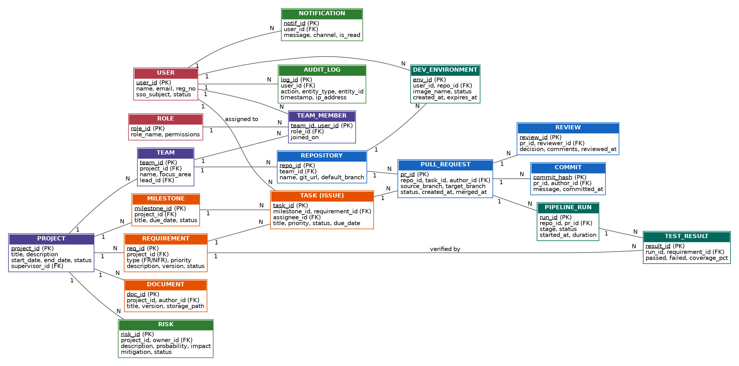
Figure 2: Entity-Relationship Diagram of the Collaboration Platform

4.8 External Interface Requirements

4.8.1 System context
Figure 3 shows the platform as a single process and the data it exchanges with users and external systems. Solid arrows enter the platform; dashed arrows leave it.
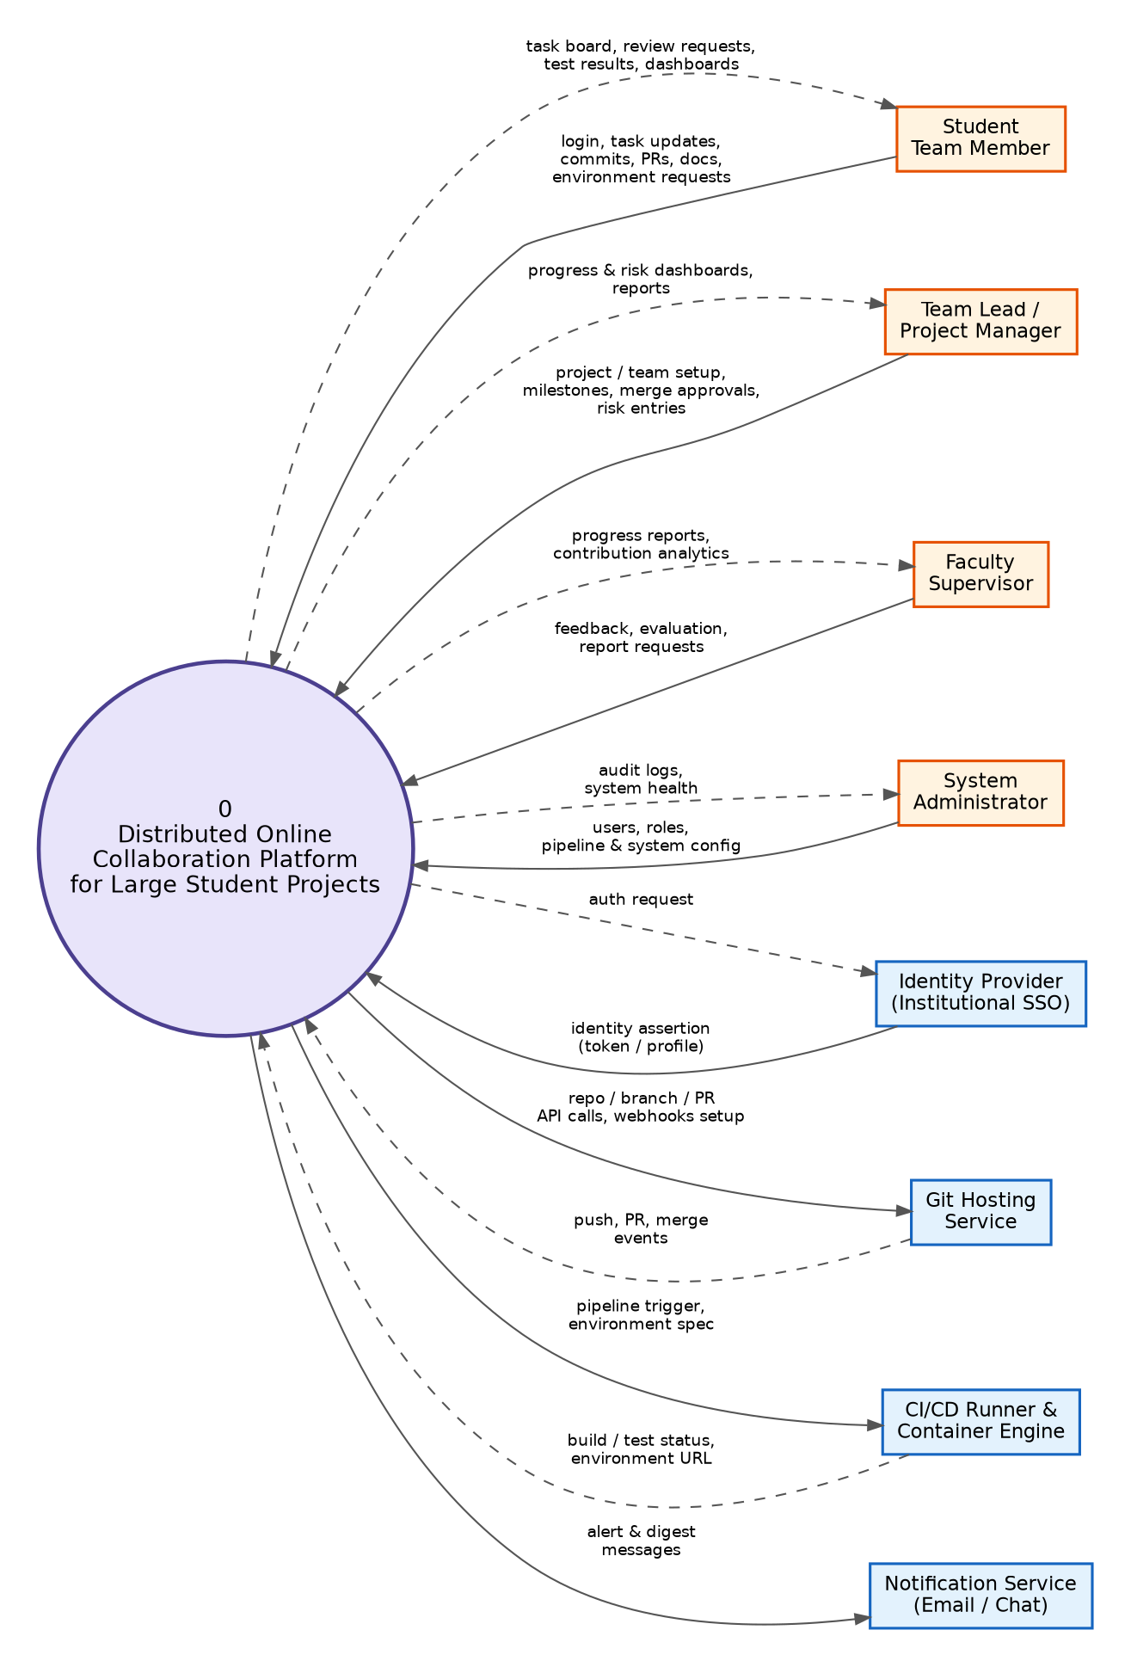
Figure 3: System Context Diagram (Level 0 data-flow view)

4.8.2 User interfaces
- Responsive web interface with role-specific home page: board and 'my work' for students, planning and risk view for leads, summary dashboards for faculty, admin console for administrators.
- Consistent navigation: Projects → Teams → Tasks / Docs / Code / Pipelines / Dashboard; global search; notification centre.
- Accessibility to WCAG 2.1 AA, keyboard navigation, colour-blind-safe status colours; English interface with provision for localisation.
- Error messages state the cause and the corrective action; destructive actions need confirmation.

4.8.3 Hardware interfaces
No special hardware. Servers: x86-64 / ARM64 Linux hosts (minimum starting capacity: 16 vCPU, 64 GB RAM for services, auto-scaling worker nodes for CI and environments). Users need a device with a modern browser; Git command-line users need a standard workstation.

4.8.4 Software and communication interfaces
Interface | Protocol / standard | Data exchanged | Direction
Identity Provider | OpenID Connect / SAML 2.0 over HTTPS | Authentication request, identity token, profile | Both
Git Hosting Service | Git over HTTPS / SSH; REST API; webhooks | Repositories, branches, commits, PR events, merge commands | Both
CI/CD Runner | REST API; webhooks; message queue | Pipeline trigger, job status, logs, artefacts, test reports | Both
Container Engine / Orchestrator | OCI image spec; Kubernetes API | Create / suspend / delete environment, resource usage | Platform → Engine
Notification Service | SMTP, chat webhook (REST) | Alert and digest messages | Platform → Service
Database | SQL over TLS | Entity data | Both
Object storage | S3-compatible API | Documents, artefacts, logs | Both
Platform public API | REST / JSON, OpenAPI 3, token authentication | All functions for scripting and future LMS integration | Both

All external communication uses TLS 1.2 or higher; webhooks are signed and verified; API calls are rate-limited per user to protect availability.

4.9 System Features
ID | Feature | Priority | Description | Typical stimulus → response | Requirements
F-1 | Identity & Access Control | High | Single sign-on, roles and permissions for all resources. | User signs in → session and role-based menu appear; unauthorised action → denied and logged. | FR-01 – FR-04
F-2 | Project, Team & Task Management | High | Projects, teams, milestones, task board, dependencies, reminders and duplicate warning. | Lead creates task → assignee notified, board and dashboard updated. | FR-05 – FR-12
F-3 | Requirements & Documentation | High | Versioned requirements, collaborative documents, templates, traceability matrix. | Member edits SRS → new version stored, collaborators see change, matrix refreshed. | FR-13 – FR-17
F-4 | Version Control & Code Review | High | Repositories, protected branches, pull requests, reviews, conflict detection, contribution statistics. | Author opens PR → pipeline and reviewers triggered; merge blocked until rules are satisfied. | FR-18 – FR-23
F-5 | Containerised Environments | Medium | On-demand reproducible workspaces with quotas, auto-suspend and persistent volume. | Student requests environment → ready in ≤ 2 min with repo checked out. | FR-24 – FR-26
F-6 | Automated Testing & CI/CD | High | Pipelines as code, isolated test execution, quality gates, staging deployment, artefacts. | Push event → build and tests run → status posted on PR; merge triggers deployment. | FR-27 – FR-32
F-7 | Progress Tracking, Dashboards & Risk | High | Live dashboards, risk register, automatic risk flags, reports. | Task overdue / build failing repeatedly → risk flag and alert to lead; faculty exports report. | FR-33 – FR-36
F-8 | Notification, Audit, History & Administration | High | Alerts, immutable audit trail, history and restore, archival, evaluation, configuration. | Any significant action → audit record; deadline near → reminder; term end → archive. | FR-37 – FR-42

Feature prioritisation (MoSCoW)
Priority | Release | Features / requirements
Must have | Release 1 (months 1 – 3) | Core: SSO, RBAC, projects / teams / tasks, requirements & documents, Git workflow with review and protection, CI pipeline with test gate, dashboards, notifications, audit trail and history.
Should have | Release 2 (month 4) | Containerised environments quotas, staging deployment / rollback, risk register and flags, duplicate-task check, reports, archival, evaluation remarks, admin console.
Could have | Later | Browser IDE / SSH access, export to multiple formats, advanced analytics, mobile app, LMS integration.

Rationale: Must-have items directly remove the four problems named in the problem statement (duplication, conflicts, missed deadlines, inconsistent documentation); Should-have items improve efficiency and assessment support; Could-have items are valuable but not needed to prove the concept.

4.10 Supporting Models: Workflow and Architecture

4.10.1 Contribution workflow (activity diagram)
Figure 4 shows how UC-08, UC-09, UC-10, UC-11, UC-12 and UC-13 work together as one end-to-end flow across the four swimlanes. It also shows the two feedback loops that prevent defects and conflicts from reaching the main branch.
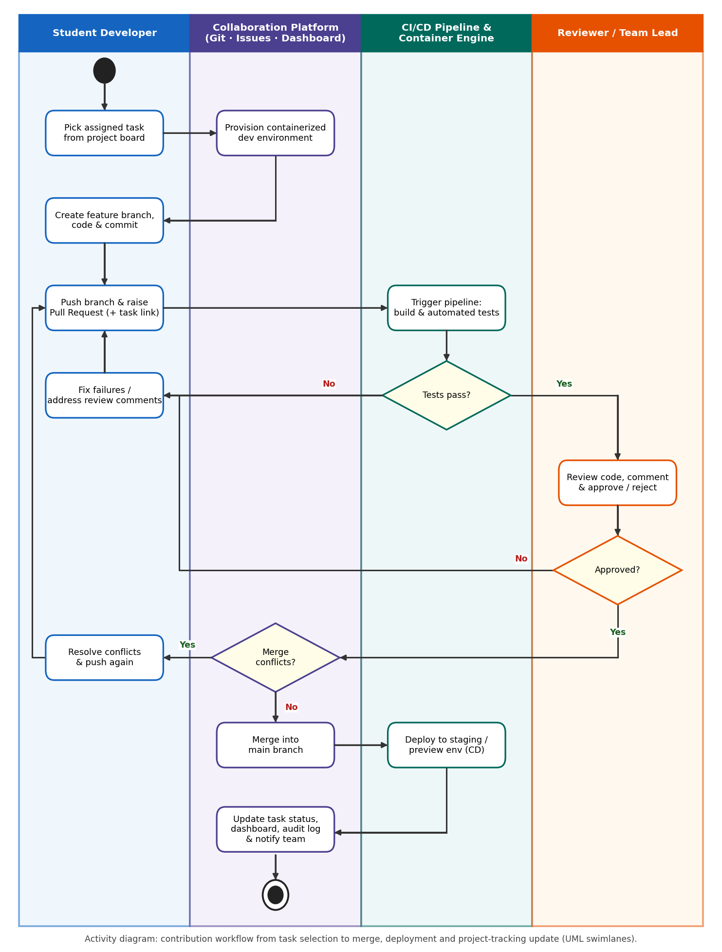
Figure 4: Activity Diagram (swimlanes) – from task selection to merge, deployment and tracking

4.10.2 Architecture satisfying scalability and availability requirements
The platform is built as six layers. Application services are stateless and containerised so that they can be replicated behind the load balancer; an event bus decouples services from pipeline orchestration, so heavy CI work never slows down the user interface; CI runners and environments scale out as separate worker pools; data stores are replicated and backed up.
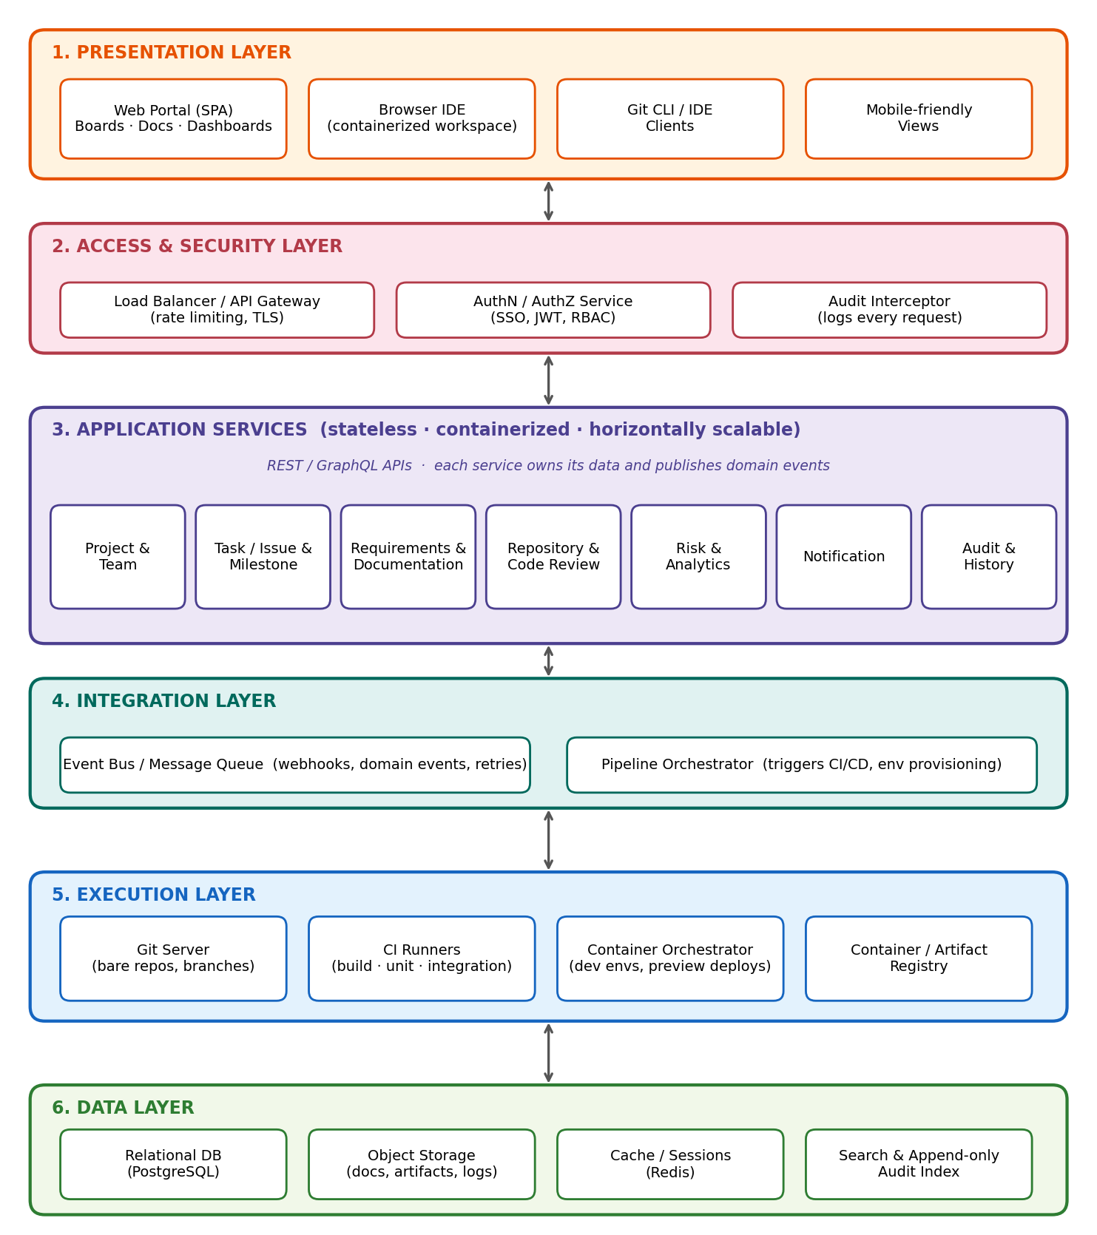
Figure 5: Layered System Architecture
Quality requirement | Architectural tactic
Scalability (NFR-04) | Stateless services + load balancer; auto-scaling worker pools; database read replicas; object storage for large files.
Performance (NFR-01 – 03) | Caching (Redis) of dashboards and permissions; asynchronous processing through the event bus; pre-pulled base images for fast environment start.
Availability / reliability (NFR-08, 09) | Multiple replicas across nodes; health checks and automatic restart; replicated database with point-in-time recovery; retried jobs.
Security (NFR-05 – 07) | Central AuthN/AuthZ at the gateway; per-service least privilege; isolated, non-root job containers with network policies; secrets vault.
Maintainability (NFR-12, 13) | Small services with OpenAPI contracts; central logs and metrics; platform's own CI/CD.
Auditability (NFR-15) | Audit interceptor at the gateway writes to an append-only store; no update / delete interface.

PART 5 – ASSUMPTIONS AND CONSTRAINTS

5.1 Assumptions
Assumptions are conditions believed to be true; if any proves false, the requirements or schedule must be re-examined.
ID | Assumption | Risk if false
A1 | All students and faculty have valid institutional accounts and the institution provides an SSO service (OIDC / SAML). | Local account management and password reset effort increases.
A2 | Students have reliable internet access and a device with a modern browser. | Browser-based IDE and environments become unusable for some users.
A3 | Users have basic Git knowledge or receive a short orientation session (≤ 2 hours) at project start. | Higher support load; more conflicts.
A4 | The institution provides server / cloud capacity for the stated user load (5,000 users, 500 teams) and a Kubernetes or container host. | Scalability targets cannot be met; queueing of CI jobs.
A5 | Open-source components (Git server, CI runner, container runtime, PostgreSQL) are acceptable to the institution. | Licence cost increases.
A6 | Each project has a nominated faculty supervisor who defines milestones and approves roles. | Dashboards and evaluation features lose value.
A7 | Student projects are mainly software (code-centric); other deliverables are documents or presentations stored as files. | Additional tooling is needed for hardware / design artefacts.
A8 | Peak load occurs around milestone reviews and final submission; usage outside the academic term is low. | Capacity planning must be revised.
A9 | English is the working language of the platform and of project documents. | Localisation requirement is added.
A10 | External services (IdP, e-mail / chat gateway) have documented, stable APIs and agreed availability. | Degraded login or notifications.

5.2 Constraints
Category | Constraint | Effect on the requirements
Technical | Must use the standard Git protocol and OCI containers; web-based, no client installation; must integrate with the institutional SSO; CI runner capacity and compute are limited and shared. | Interoperability (NFR-14), quotas (FR-25), queueing of pipelines.
Technical | Must run on Linux; data-store and message-queue choices must be open-source and supported by the team. | Architecture in Section 4.10.
Operational | Must be operated by a small IT team; maintenance only outside submission periods; students need minimal training. | Monitoring, automation, usability targets (NFR-09, 10, 13).
Operational | Must remain available near deadlines; backups and restore must be tested each term. | NFR-08, NFR-09.
Economic | Limited institutional budget – no per-user commercial licences; infrastructure cost capped per term; resources shared between projects. | Open-source stack, quotas, auto-expiry of environments.
Legal / regulatory | Must comply with the Digital Personal Data Protection Act 2023 (India), institutional data and IT-usage policies; open-source licences (e.g. GPL / AGPL / Apache) must be respected; academic-integrity rules apply to contributions. | NFR-16, audit trail (FR-38), data retention (Section 4.7).
Legal / regulatory | Student personal data must be stored within the country / institution-approved region. | Hosting location decision.
Time | Must be ready for use in one academic term: Release 1 in about 3 months, Release 2 in the 4th month; pilot with one department before wide roll-out. | MoSCoW release plan (Section 4.9).
Resource (people) | Development by a student / faculty team with limited experience in DevOps tooling. | Prefer proven open-source components over custom build; modular design.

Indicative schedule
Phase | Duration | Deliverables
1. Requirements & design | Weeks 1 – 3 | Approved SRS (this document), architecture, UI prototype.
2. Core build (Release 1) | Weeks 4 – 12 | Identity, projects / tasks, documents, Git workflow and review, CI with test gate, dashboards, notifications, audit trail.
3. Extended build (Release 2) | Weeks 13 – 16 | Environments, staging deployment, risk register, reports, archival, admin console.
4. Pilot & hardening | Weeks 17 – 20 | Pilot with one department, load test, security review, user training, corrections.

PART 6 – VALIDATION OF REQUIREMENT COMPLETENESS AND CONSISTENCY
Validation was performed by (1) tracing every stakeholder need to requirements and use cases, (2) reviewing each requirement against the quality attributes of a good requirement (complete, unambiguous, consistent, verifiable, feasible, traceable) and (3) cross-checking the models (use case, activity, ER, architecture) against the written requirements.

6.1 Stakeholder Requirement Coverage
Objective / expected outcome from the problem statement | Requirements | Use cases | Covered?
Manage project teams, tasks, milestones and responsibilities | FR-05 – FR-12 | UC-02, UC-04, UC-05 | Yes
Support collaborative requirements and documentation | FR-13 – FR-17 | UC-06 | Yes
Integrate version control and code reviews | FR-18 – FR-23 | UC-08 – UC-11 | Yes
Provide automated testing and CI/CD | FR-27 – FR-32 | UC-12, UC-13, UC-20 | Yes
Track project progress and risks | FR-33 – FR-36 | UC-14, UC-15, UC-17 | Yes
Support containerised development environments | FR-24 – FR-26 | UC-07 | Yes
Maintain project history and audit trails | FR-38, FR-39, FR-41 | UC-16 | Yes
Role-based access (integration list in problem statement) | FR-01 – FR-04 | UC-01, UC-03 | Yes
Project dashboards (integration list in problem statement) | FR-33, FR-16, FR-23 | UC-14 | Yes
Improve collaboration among student teams | FR-08 – FR-10, FR-14, FR-37 | UC-04, UC-06, UC-19 | Yes
Reduce duplicated work and merge conflicts | FR-11, FR-21, FR-22 | UC-04, UC-10, UC-11 | Yes
Improve project visibility | FR-33, FR-35, FR-36 | UC-14, UC-15, UC-17 | Yes
Strengthen software-engineering practices | FR-15, FR-16, FR-20, FR-22, FR-29 | UC-09, UC-10, UC-12 | Yes
Improve quality through testing and reviews | FR-20, FR-27 – FR-29 | UC-09, UC-12 | Yes
Better project-management evidence | FR-23, FR-38, FR-39, FR-42 | UC-16, UC-18 | Yes

Result: all 7 objectives, 2 additional integration items and 6 expected outcomes are traceable to at least one functional requirement and one use case. Every functional requirement FR-01 to FR-42 maps to at least one use case, and every use case UC-01 to UC-20 is supported by at least one requirement (no orphan requirements or use cases).

6.2 Check for Ambiguity
Ambiguous wording in the problem statement / first draft | Problem | Resolution in the SRS
'Large student projects' | Size not defined. | Defined as 5 – 50 teams per project; platform sized for 5,000 users, 500 teams (NFR-04).
'Role-based access' | Roles and permissions not named. | Six roles listed in FR-02; permission matrix to be derived per role.
'Integrate version control' | Which VCS and which operations? | Standard Git; branch, push, pull request, review, merge, protected branches (FR-18 – FR-22).
'Automated testing' | Test types and when they run? | Build, static analysis, unit and integration tests on every push / PR (FR-27, FR-28).
'Project dashboards' / 'visibility' | Which information? | Specific metrics listed in FR-33.
'Quickly', 'user-friendly', 'secure' | Not measurable. | Replaced by measurable criteria in NFR-01 – NFR-11.
'Containerised environments' | Who creates the image, how long does it live? | Image defined per repository; quotas, auto-suspend and expiry (FR-24, FR-25).
'Risks' | How are they found? | Manual risk register plus automatic flags with named triggers (FR-34, FR-35).

6.3 Check for Redundancy
Finding | Action taken
Reminders appeared both under task management and notification features. | Reminder rule kept in FR-12; delivery mechanism only in FR-37.
Audit trail and project history overlapped. | Separated: FR-38 = security / action log (append-only); FR-39 = content versions that can be restored.
Dashboard (FR-33) and reports (FR-36) listed similar metrics. | Dashboard = live view; report = exported snapshot for evaluation.
Contribution statistics required in both code and evaluation sections. | Single requirement FR-23, referenced by UC-14 and UC-18.

6.4 Check for Inconsistency
Potential conflict | Resolution
FR-22 (merge blocked until checks pass) vs. urgent fixes before a demo. | Administrator emergency override with mandatory reason, recorded in the audit trail (UC-10 E2).
NFR-09 (high availability) vs. maintenance work. | Maintenance only in announced windows and never within 48 h of a declared deadline.
FR-25 (auto-expire environments) vs. risk of losing student work. | Persistent workspace volume retained; only the compute container is removed.
NFR-15 / FR-38 (immutable audit logs) vs. NFR-16 (erasure of personal data). | Audit logs store pseudonymous user IDs; personal profile data can be erased without breaking log integrity.
FR-04 (MFA) vs. NFR-10 (ease of use). | MFA mandatory only for privileged roles; students use SSO.
FR-02 roles vs. 'Reviewer' mentioned as an actor. | Reviewer treated as a role played by existing actors (Section 3.1).
Use case diagram shows UC-01 linked to actors only. | UC-01 is implicitly included by every use case – stated in Section 3.4 to avoid an unreadable diagram.

6.5 Missing Requirements Identified and Added
The review of the original problem statement against typical platform needs revealed requirements that were not stated but are necessary. They were added to the SRS:
Gap | Added as
No requirement for account administration and bulk onboarding of students. | FR-03
No protection for privileged accounts / session management. | FR-04
Deadlines and dependencies not explicitly managed. | FR-12
Document templates and export were missing. | FR-15, FR-17
Resource control of environments (cost, fairness) not stated. | FR-25
Retention of artefacts and logs not stated. | FR-32, Section 4.7
Administrative configuration and end-of-term archival not stated. | FR-40, FR-41
Faculty evaluation support (assessment evidence) not captured as function. | FR-42
Backup, disaster recovery, accessibility, privacy and capacity not stated. | NFR-08, NFR-11, NFR-16, NFR-17

6.6 Requirement Quality Checklist
Quality attribute | Check performed | Status
Complete | All objectives, outcomes, actors and use cases have requirements; interfaces and data specified. | Pass
Correct | Reviewed against the problem statement and stakeholder needs. | Pass
Unambiguous | Each requirement has one interpretation; vague terms replaced by measures (6.2). | Pass
Consistent | Conflicts resolved (6.4); terminology uniform (e.g. 'pull request', 'task'). | Pass
Verifiable | Each FR has a use case flow; each NFR has a metric. | Pass
Traceable | Unique IDs; objective → FR → UC → feature mapping (6.1, 4.4, 4.9). | Pass
Feasible | Uses proven open-source technologies; phased delivery (5.2). | Pass – risks noted in 5.1
Prioritised | MoSCoW priority on every functional requirement. | Pass

6.7 Suggestions to Improve Quality and Completeness
- Acceptance criteria: add Given-When-Then acceptance tests to every Must-have requirement before design starts.
- Formal review: hold a walkthrough / inspection of this SRS with faculty, student leads and the administrator, and record defects found.
- Prototype: build clickable wireframes of the board, pull-request and dashboard screens and validate them with 5 – 10 students and 2 faculty members (reduces usability risk).
- Change control: baseline this SRS, manage every change through a request, impact analysis and approval so that requirements stay consistent.
- Permission matrix: derive a detailed role × function table from FR-02 to remove remaining doubt about who can do what.
- Non-functional verification: plan load testing (1,000 concurrent users), security testing (OWASP Top-10), and a restore drill before the pilot.
- Pilot feedback loop: collect usage metrics and satisfaction data from the pilot to refine priorities for Release 2.
- Future enhancements: code-similarity checking for academic integrity, AI-assisted conflict and risk prediction, LMS grade-book integration and a mobile client.

6.8 Conclusion
The Software Requirement Specification for the Distributed Online Collaboration Platform covers the business context, stakeholders, 42 prioritised functional requirements, 17 measurable non-functional requirements, 20 use cases with a UML use case diagram, detailed use case descriptions, data, interface and feature specifications, and explicit assumptions and constraints. Validation shows full traceability from every objective in the problem statement to requirements and use cases, and the identified ambiguities, redundancies, inconsistencies and gaps have been resolved. The specification is therefore complete and consistent enough to serve as the baseline for design, implementation and testing.
Rubrics for Calculation

Criteria | Excellent (4 Marks) | Good (3 Marks) | Satisfactory (2 Marks) | Needs Improvement (1 Mark)
Scenario Understanding and Problem Analysis (30%) | Demonstrates thorough understanding of the scenario, stakeholders, objectives, and business context with clear analysis. | Demonstrates good understanding with minor omissions. | Basic understanding with limited analysis. | Poor understanding; major aspects missing or incorrect.
Functional and Non-Functional Requirement Identification (25%) | Clearly identifies comprehensive, accurate, and well-classified functional and non-functional requirements. | Identifies most requirements with minor classification errors. | Identifies only basic requirements; several omissions. | Requirements are incomplete, inaccurate, or poorly classified.
Actor Identification and Use Case Modelling (20%) | Correctly identifies all relevant actors and use cases; use case diagram is complete, accurate, and follows UML standards. | Most actors and use cases identified; diagram has minor errors. | Limited actors/use cases identified; diagram partially correct. | Actors/use cases missing or incorrect; diagram absent or inaccurate.
Software Requirement Specification (SRS) Documentation (15%) | SRS is well-structured, complete, professionally organized, and includes all required sections. | SRS is organized with minor missing sections or formatting issues. | SRS includes only essential sections with limited detail. | SRS is incomplete, poorly organized, or lacks essential components.
Assumptions, Constraints, and Requirement Validation (10%) | Clearly identifies realistic assumptions and constraints; validates requirements for completeness, consistency, and ambiguity with appropriate justification. | Identifies most assumptions and constraints; validation is adequate. | Limited assumptions/constraints; validation is superficial. | Assumptions, constraints, and validation are missing or incorrect.

Criteria | Mark
Scenario Understanding and Problem Analysis (30%) | /5
Functional and Non-Functional Requirement Identification (25%) | /5
Actor Identification and Use Case Modelling (20%) | /5
Software Requirement Specification (SRS) Documentation (15%) | /5
Assumptions, Constraints, and Requirement Validation (10%) | /5
TOTAL | /25

